**Steps to install Whatsapp Module into the CRM**

Module registration in database,

**Database:**

Step 1: Register a module in database, by modifying table “**vtiger_tab**” like shown in below

**Note**: Use **mainsqlquery.txt** file for insert queries **(**make sure below tabid is **50** else update everywhere as per your tabid**)**  
  
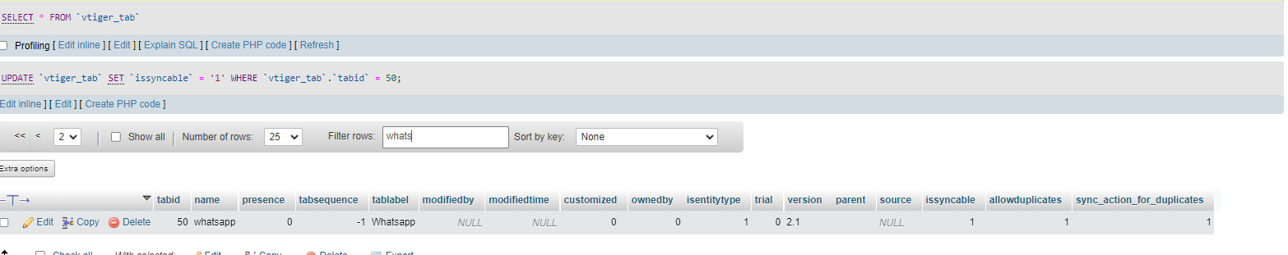

Step 2: In table “**vtiger_field**” insert below data as it is

**Note**: Use **mainsqlquery.txt** file for insert queries **(**make sure below tabid is **50** else update everywhere as per your tabid**)**

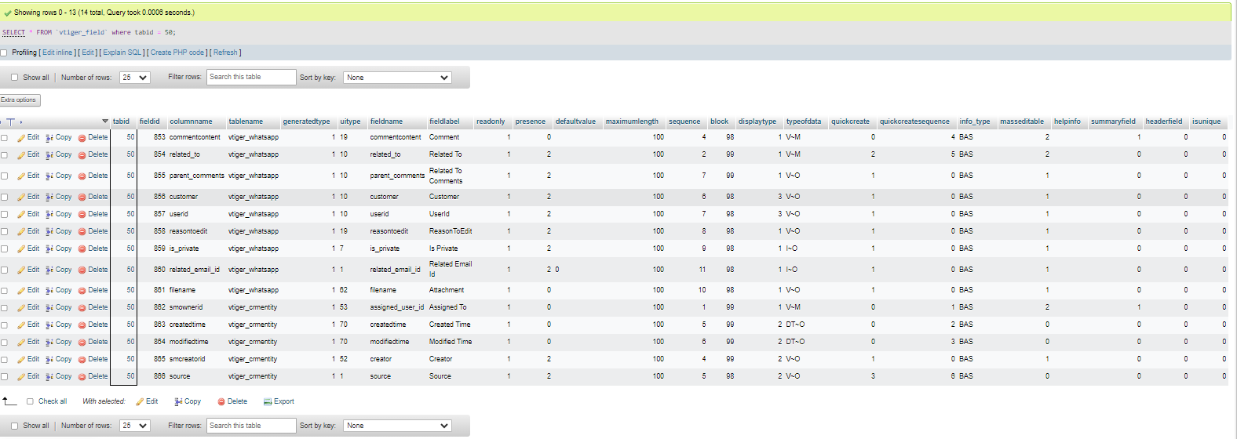

Step 3: In table “**vtiger_relatedlists**” insert below data as it is

**Note**: make sure below **relationfieldid** is **854** of **vtiger_relatedlists** table where table **vtiger_field** -> fieldid = 854 of column **columnname** = **related_to**

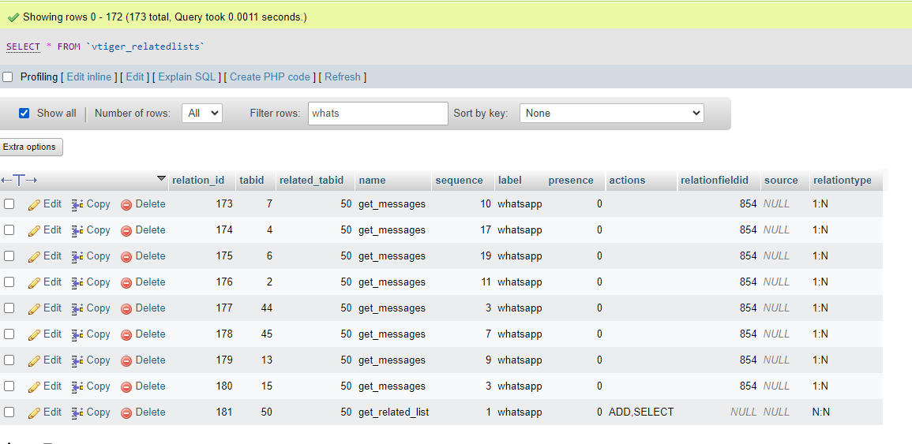

Step 4: In table “**vtiger_blocks**” insert below data as it is

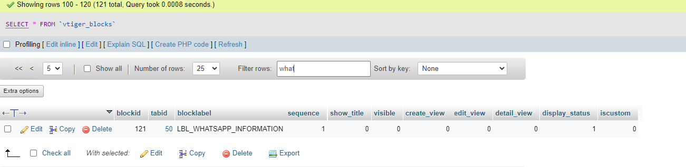

Step 5: In table “**vtiger_ws_entity**” insert below data as it is

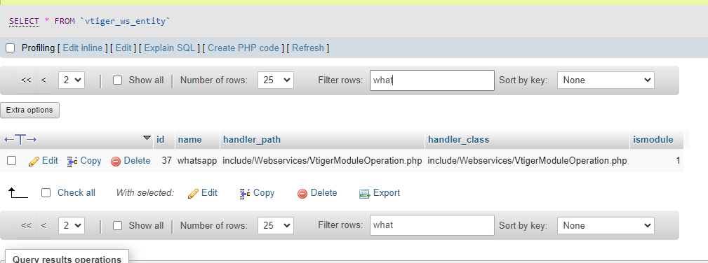

Step 6: In table “**vtiger_eventhandlers**” insert below data as it is

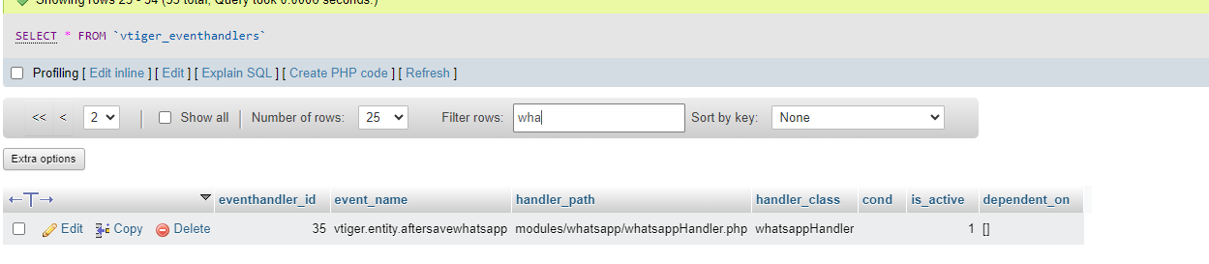

Step 7: In table “**vtiger_entityname**” insert below data as it is

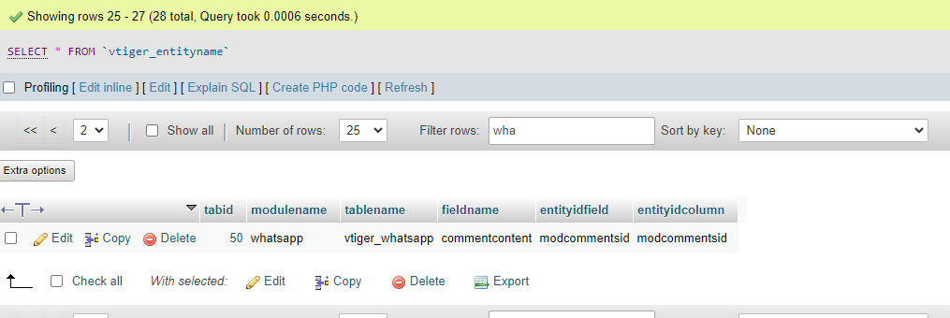

Step 8: In table “**vtiger_customview**” insert below data as it is

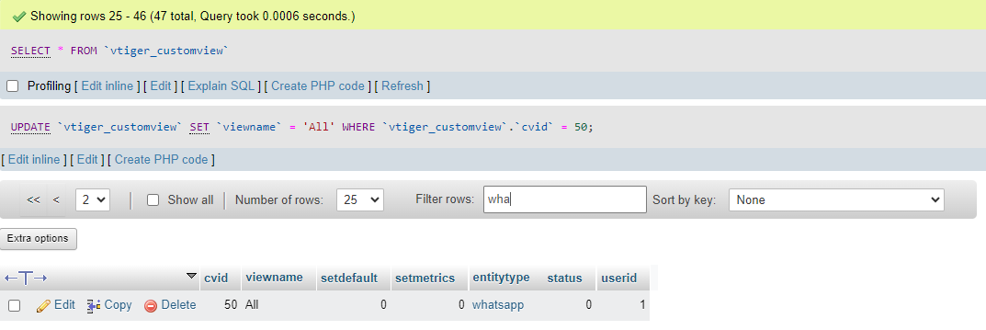

Step 9: In table “**vtiger_cvcolumnlist**” insert below data as it is

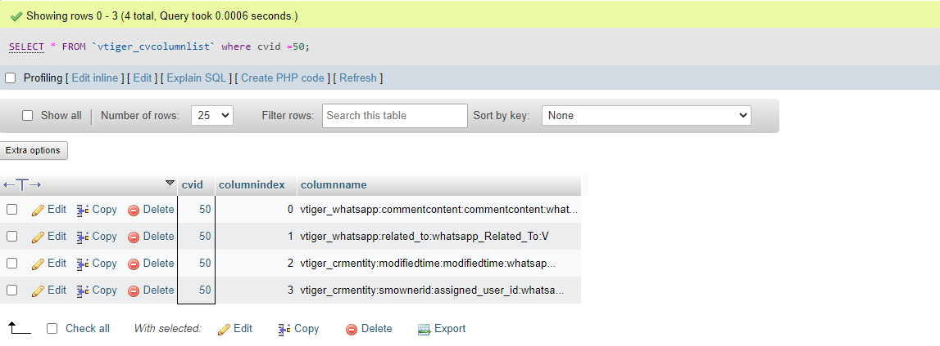

Step 10: In table “**vtiger_links**” insert below data as it is

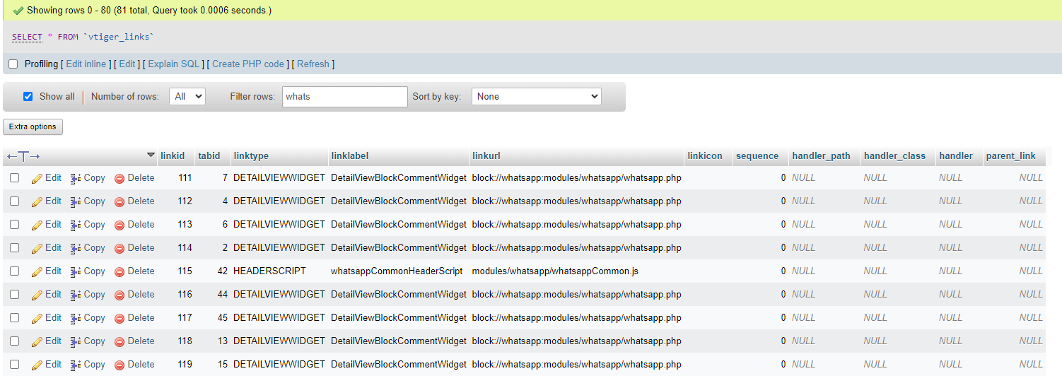

Step 10: In table “**vtiger_ws-fieldtype**” insert below data as it is

